Write a program that encrypts or decrypts a file using a cipher using a keyword similar to this.
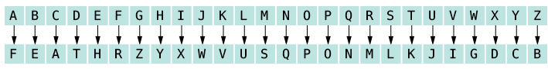
crypt -d -kFEATHER encrypt.txt output.txt
Read in command line arguments
If “d” decrypt
If “e” encrypt

Create keyword cipher:
Read in keyword, then use it to create the cypher.
Load keyword to char array
Remove duplicate letters
Initialize another char array with all of the letters of the alphabet.

Encrypt:
Load to be encrypted file.
Read in one char at a time.
Search alphabet array for the letter, then use the found index to pull the char of the same index in cipher array.
Write encrypted text to output file.
Output message that encryption was successful.

Decrypt:
Load in encrypted file.
Read one char at a time.
Search cipher array for matching letter, then use the found index to pull the char of the same index in the alphabet array.
Write decrypted text to output file.
Output message that decryption was succesful

